

Data Story Telling

By Jonah Gray



March 27, 2023

Table of Contents

**Policies and Procedures3**

**GDP Tasks3**

Transforming the Data4

Creating Visuals5,6

Filtering and Enhancing Visuals ……………………………………………………………………………. 7,8

**Additional Tasks9**

Creating Macros9

Documenting Macros10

Editing Layouts ……………………………………………………………………………………………………. 11

**Reflection** ………….……………………………………………………………………………………………………………. 12

Policies and Procedures

The main policies that need to be adhered to when working with data sets include;

* Data Protection  
   Protecting data from theft, loss or unauthorized access.
* Data Access  
   Determining who has access to data under what circumstances. May include adding access controls and ensuring access is only granted on a need-to-know basis.
* Data Privacy  
   Protecting the privacy of personal data, how it should be collected, processed and stored. It may also involve obtaining permission from people when obtaining their data.
* Data Security  
  Maintaining confidentiality and integrity of data using encryption and backups and monitored to detect potential security breaches.
* Data Retention  
  Determines how long data should be kept to fulfil its intended purpose and then securely destroyed after to minimize the risk of data breaches.

These policies are important to allow us to comply with certain data privacy legislations such as the General Data Protection Regulation and the Data Protection Act. This entails the fair and lawful use of data to protect people’s rights and regulations on how personal data can be used. It can also be used to minimize the risk of any data breaches or losses.

Data analysts should be aware of these rules as the company you work for will likely have policies and advertise to them to potential clients. Letting the clients know what rules you have in place when using their data allows a company to build trust and set expectations. It is also important for a data analyst to know these policies as it will allow them to act in a professional and lawful way when managing large amounts of data.

GDP Tasks

1. 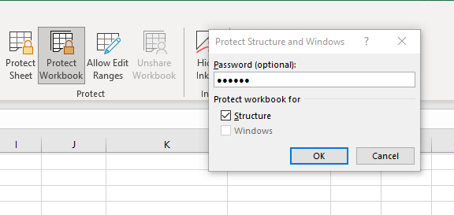The first task was to protect the workbook which can be used with the Protect Workbook feature to add a password onto the file. This makes the workbook secure and makes sure no-one can edit the file.

2. Next I corrected the format of the GDP to currency with two decimal places.

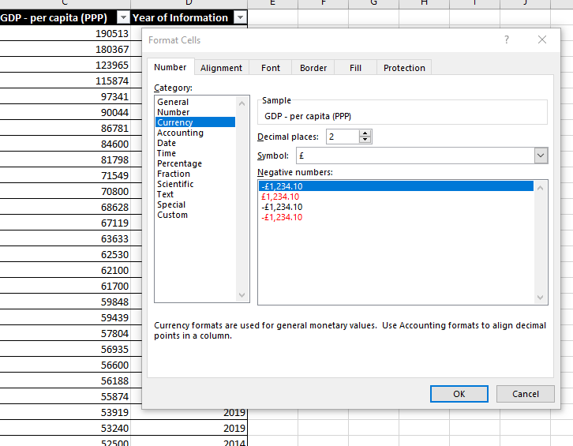

1. 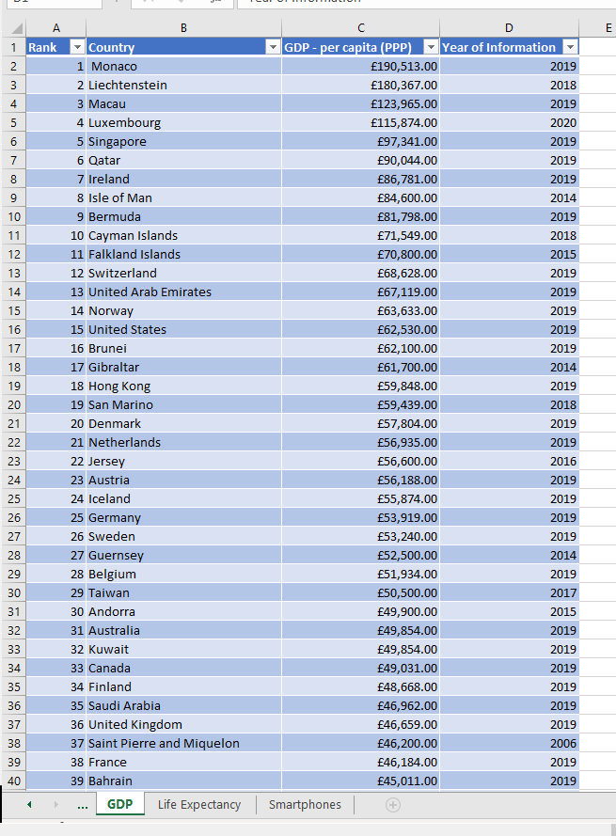Then I formatted the cells into a table to both make it visually more appealing and allows for sorting and filtering capabilities.

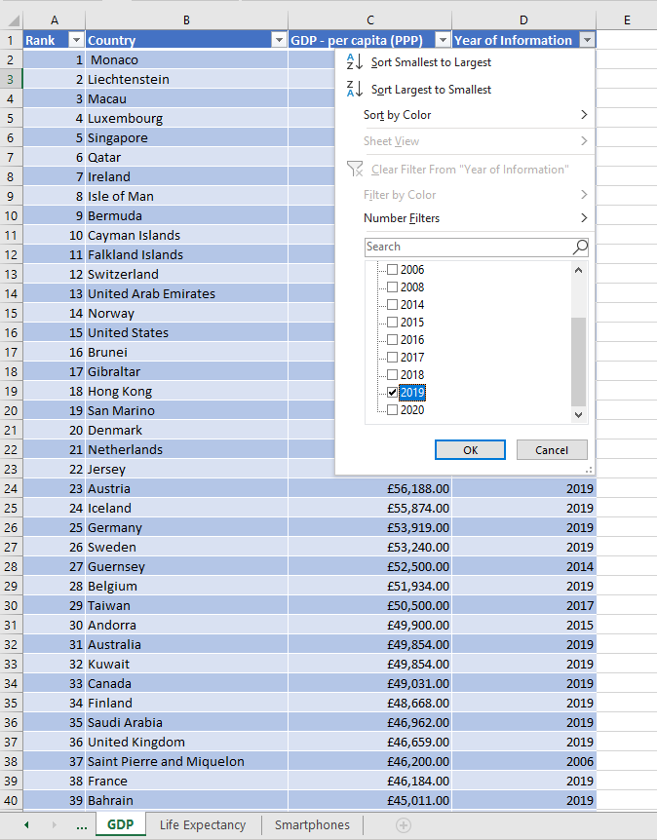  
4. I then filtered out all the other years of information except 2019 to limit the amount of information to use.

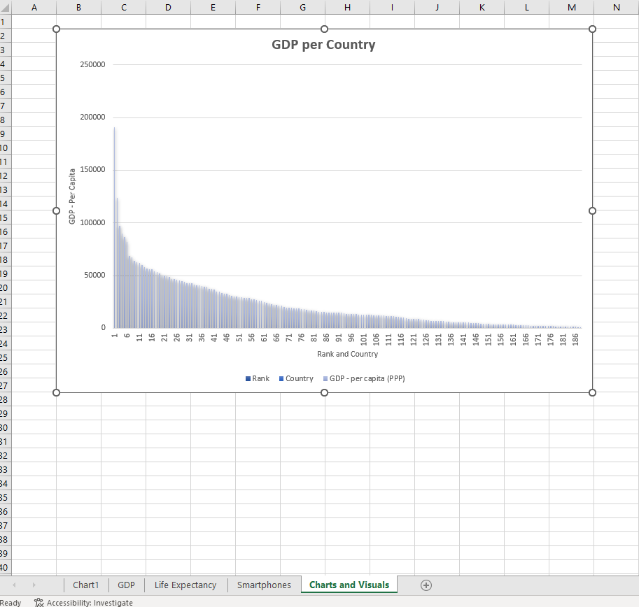5-7. Then I created a graph of the GDP per country, added a title, axis titles and some extra colour to attempt to convey some of the information easier. The chart was also moved to a new sheet for charts.

8. I then filtered for the top 20 ranked countries to decrease the sample size and allow for visual more comprehensible graphs. This one done by filtering for less than or equal to 20 on the rank column.

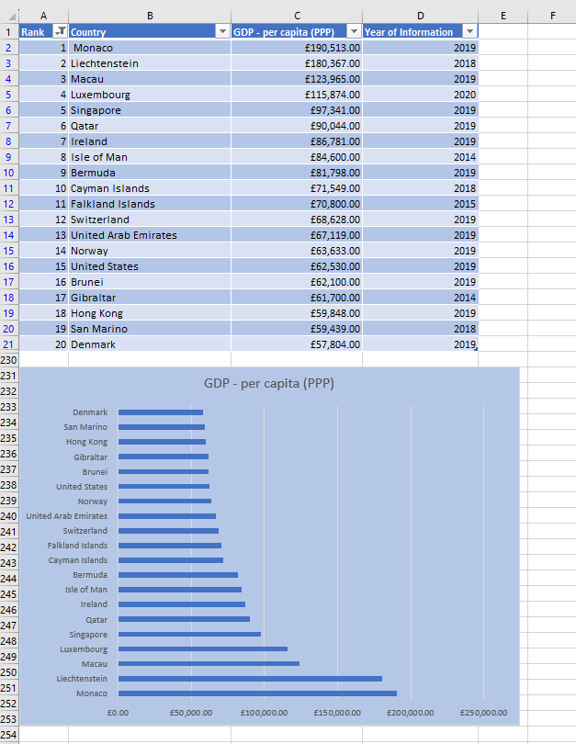9-10. Finally I created a bar chart detailing the top 20 countries in GDP and added some colour to the background to make it more dynamic and visually pleasing.

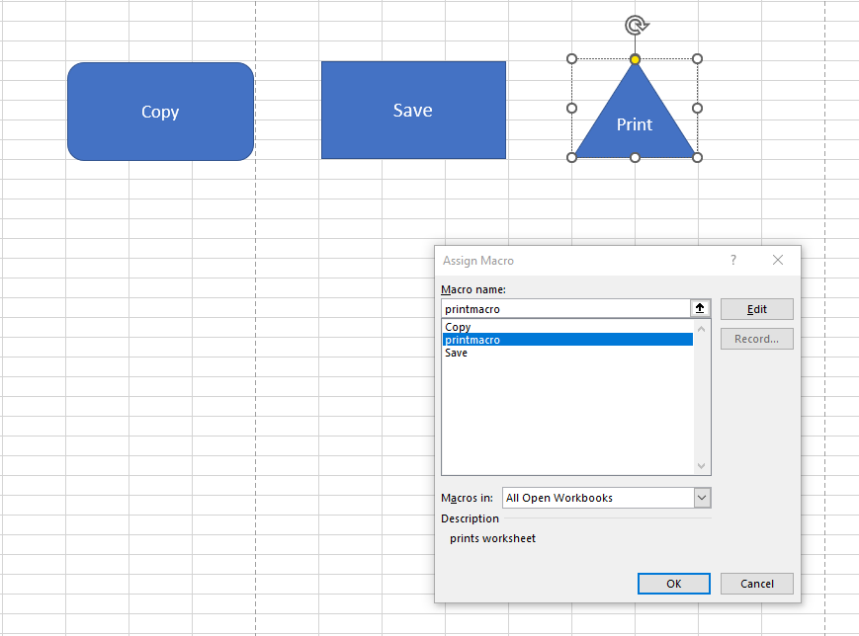11. For the next part of the task, I created 3 macros and assigned them to a button.

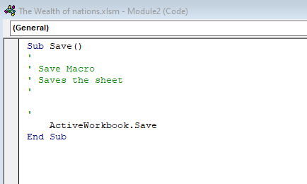

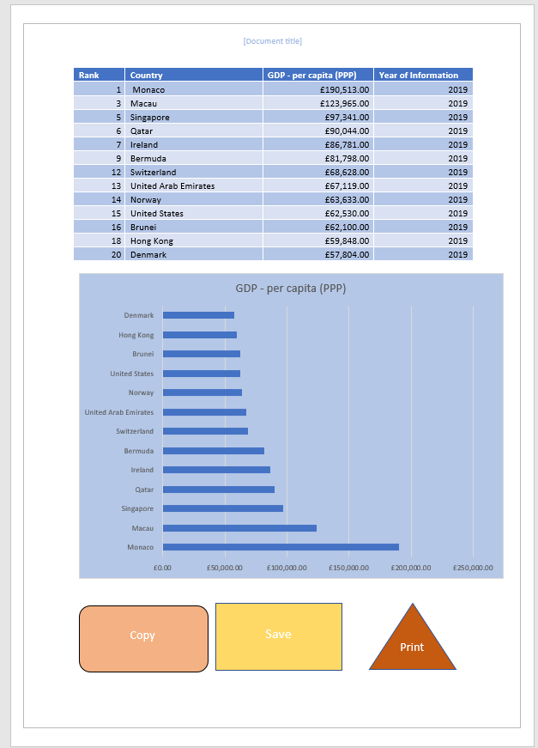12. After this I created a word document and copied the sheet onto it using the copy macro.

13. Finally 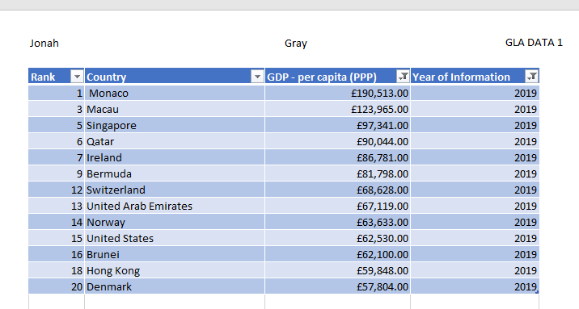I added a header to the table by changing the view of the table with page layout.

Reflective account

Overall, the report went well, the transformation of the data went very smoothly and had no problems with the majority tasks.

The only part only areas I would consider improving is adjusting or adding a filter to the first chart as it has so many values on its axis that it is hard to see individual countries on the graph and is visually very cluttered. The only task I struggled on was creating another sheet.

Ideally in the next report I attempt I will try to figure out a better way to format a multitude of screenshots in a word document as it didn’t seem very visually clean.